1. nmap 192.168.1.1
Purpose: Scan common ports
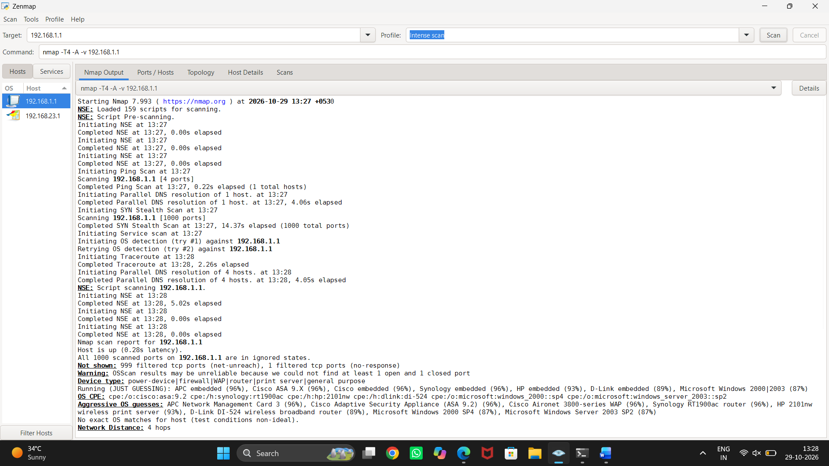
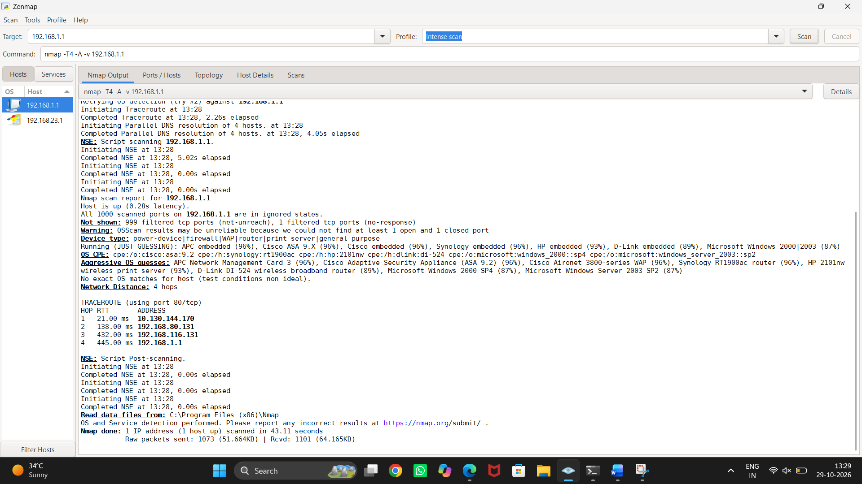

2. nmap -sn 192.168.1.0/24
Purpose: Discover live hosts
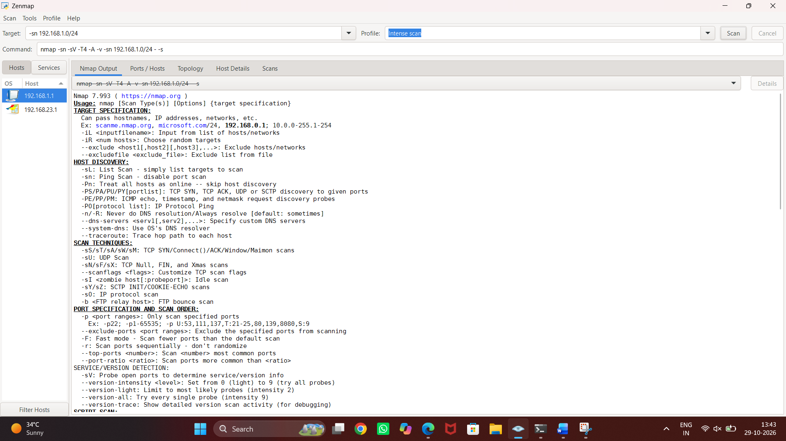
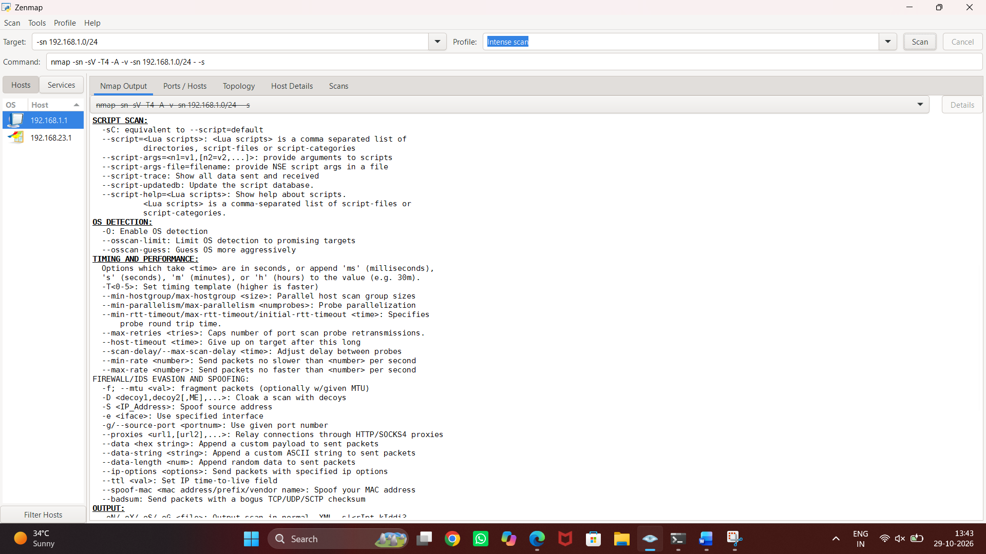
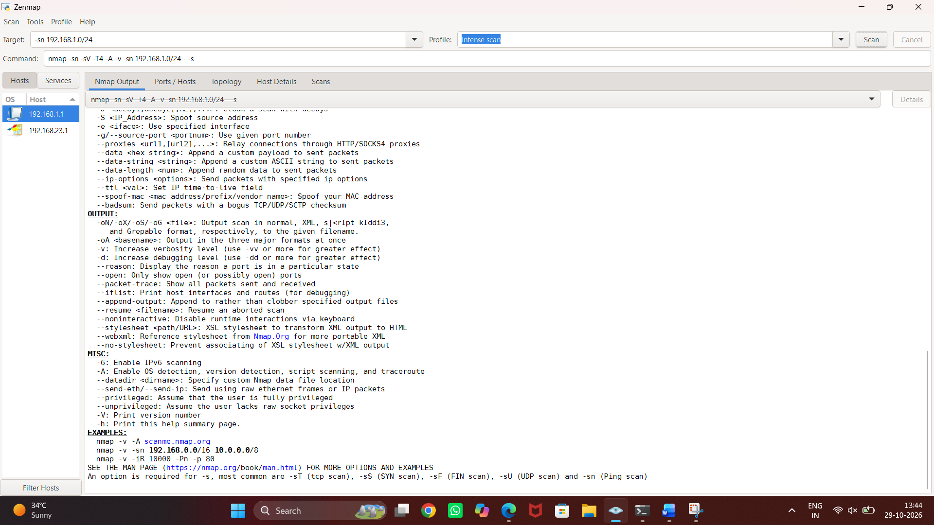

3. nmap -sV 192.168.1.1
Purpose: Detect service versions

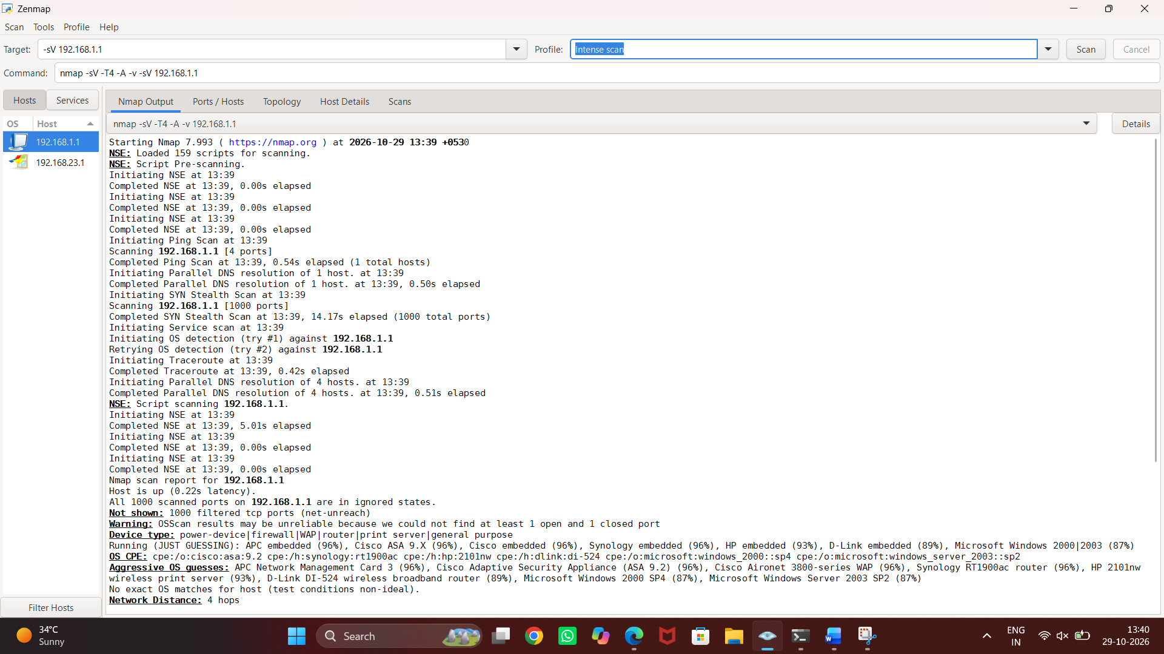
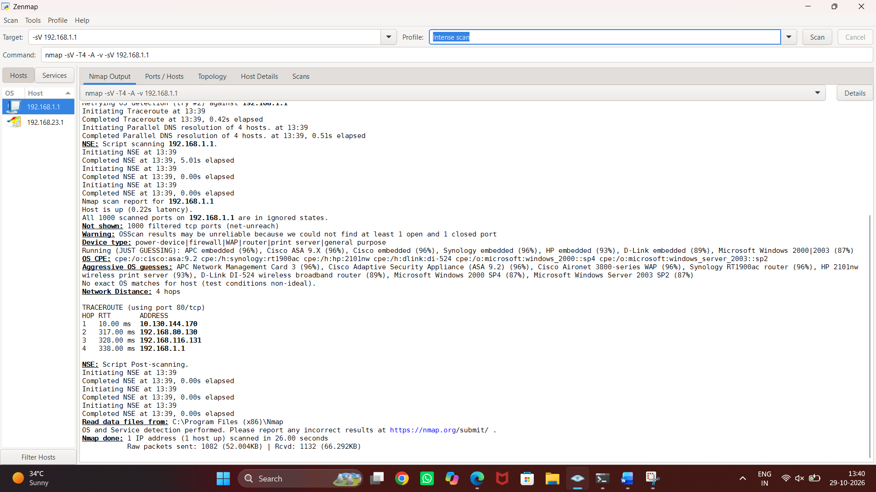

4. nmap -O 192.168.1.1 Identify the operating system
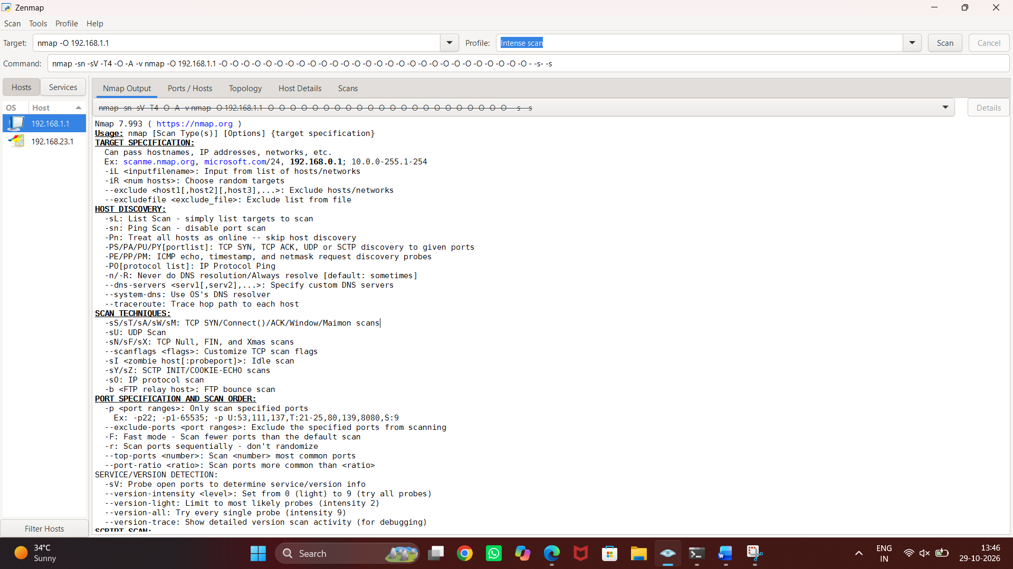
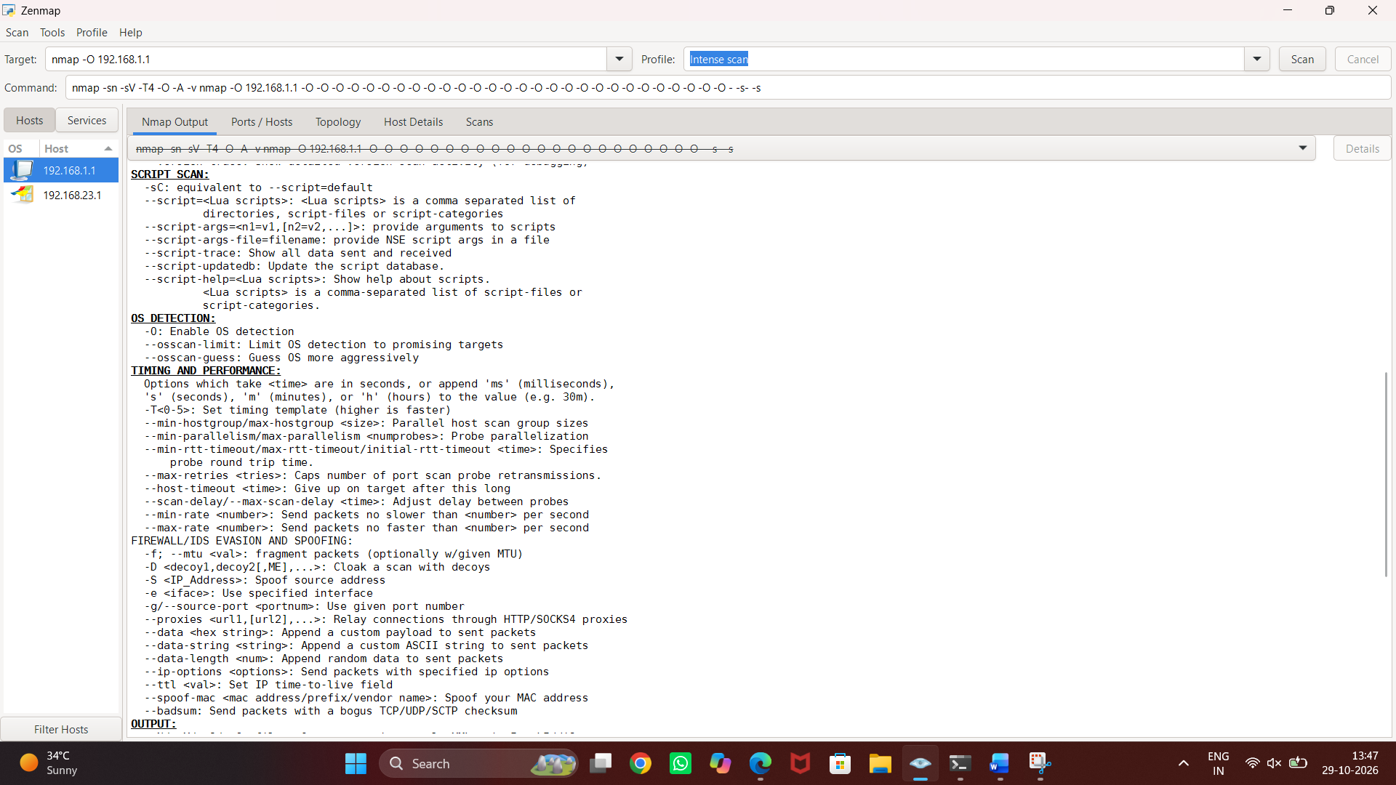
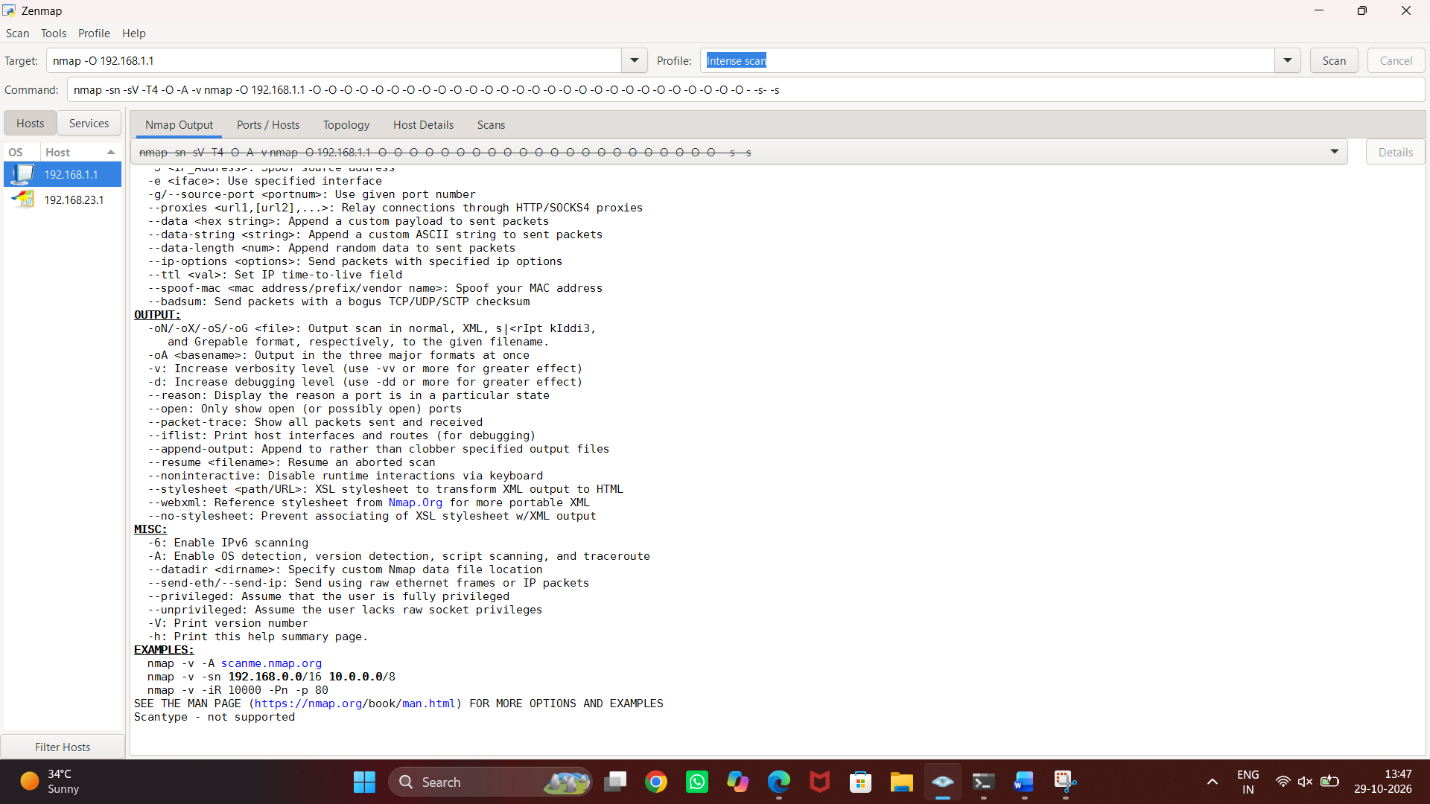

5. nmap -p 80,443 192.168.1.1
Purpose: Scan specific ports
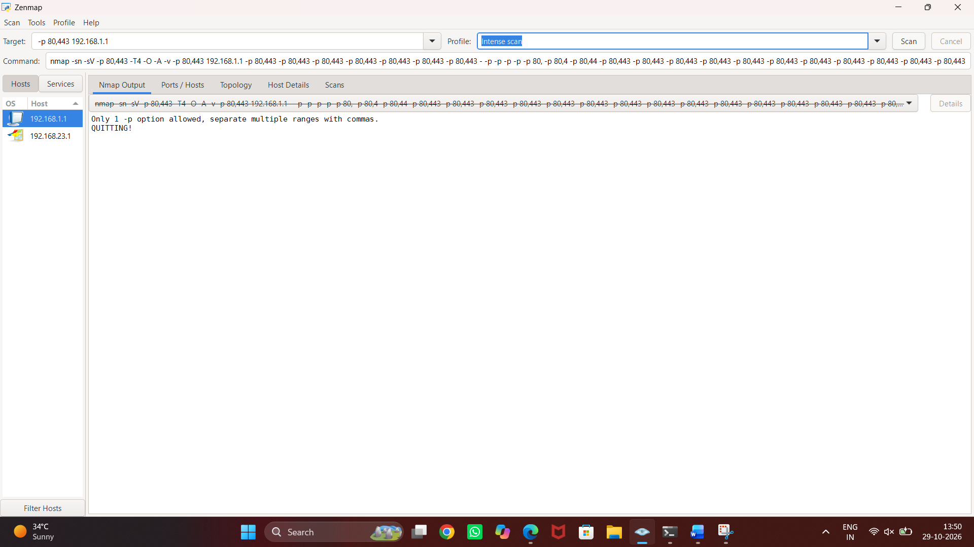

6. nmap -sC 192.168.1.1 Run default NSE scripts
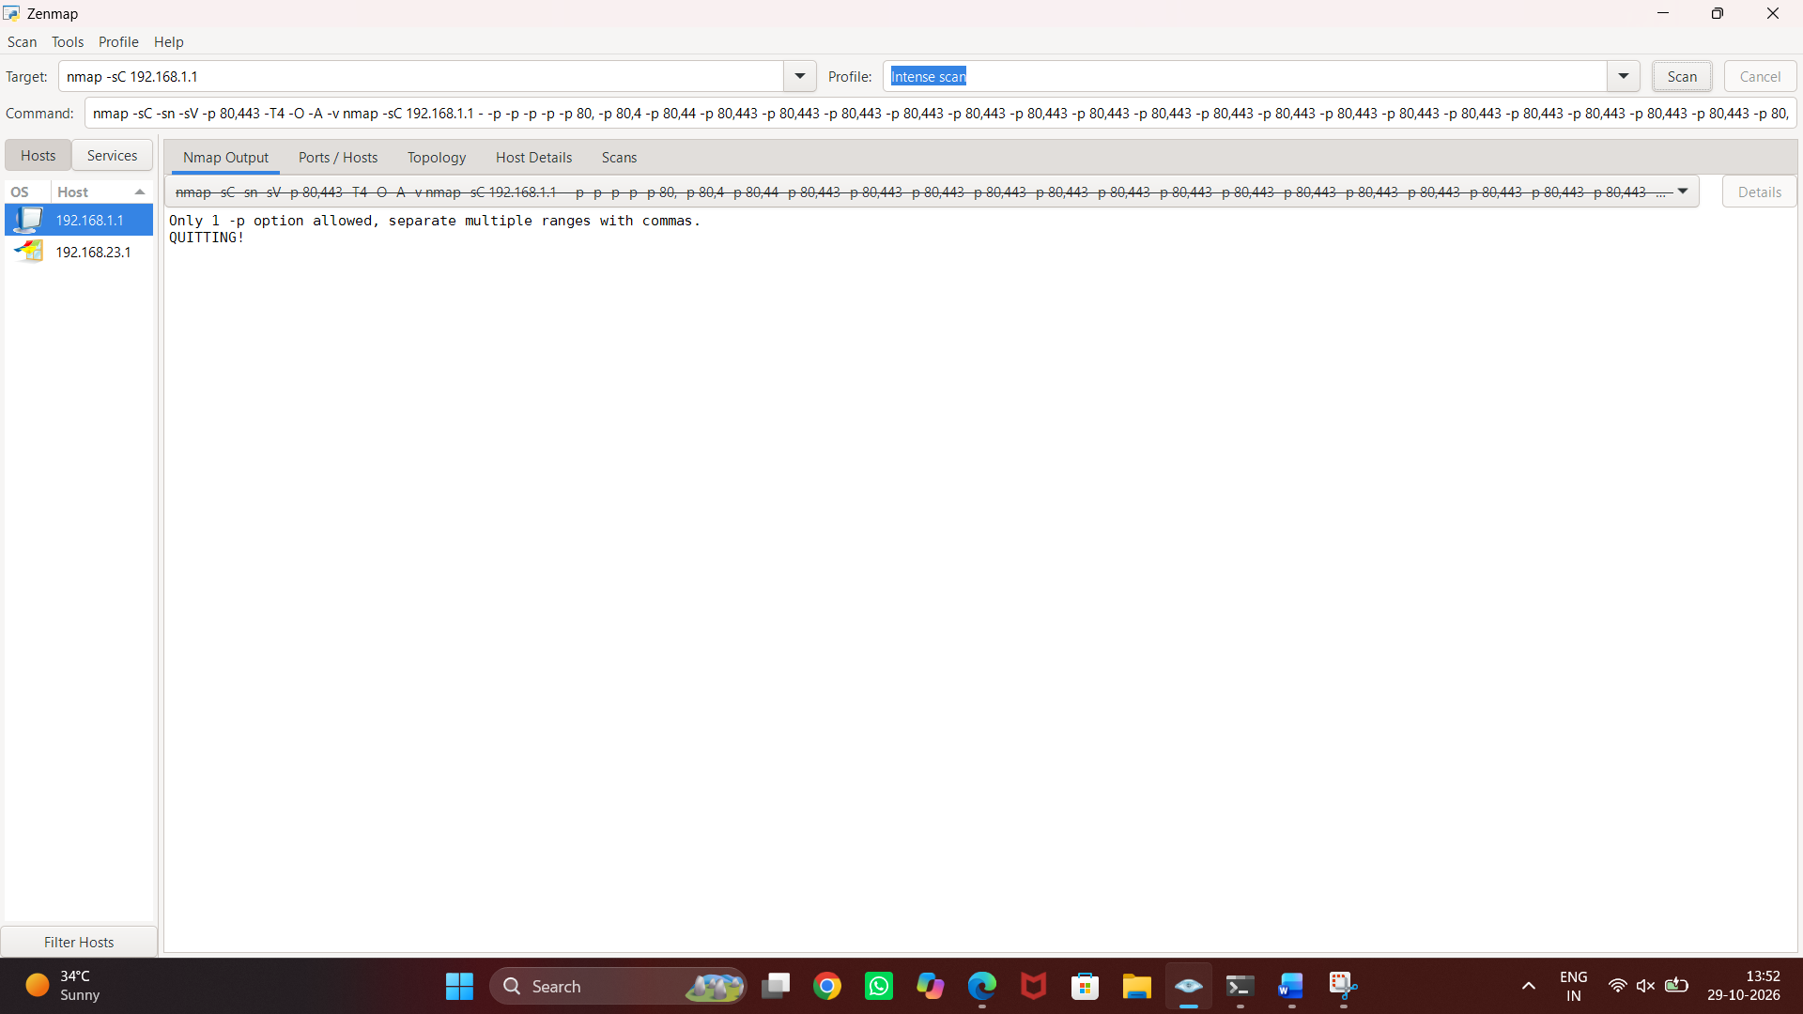

7. nmap -Pn 192.168.1.1
Purpose: Skip host discovery
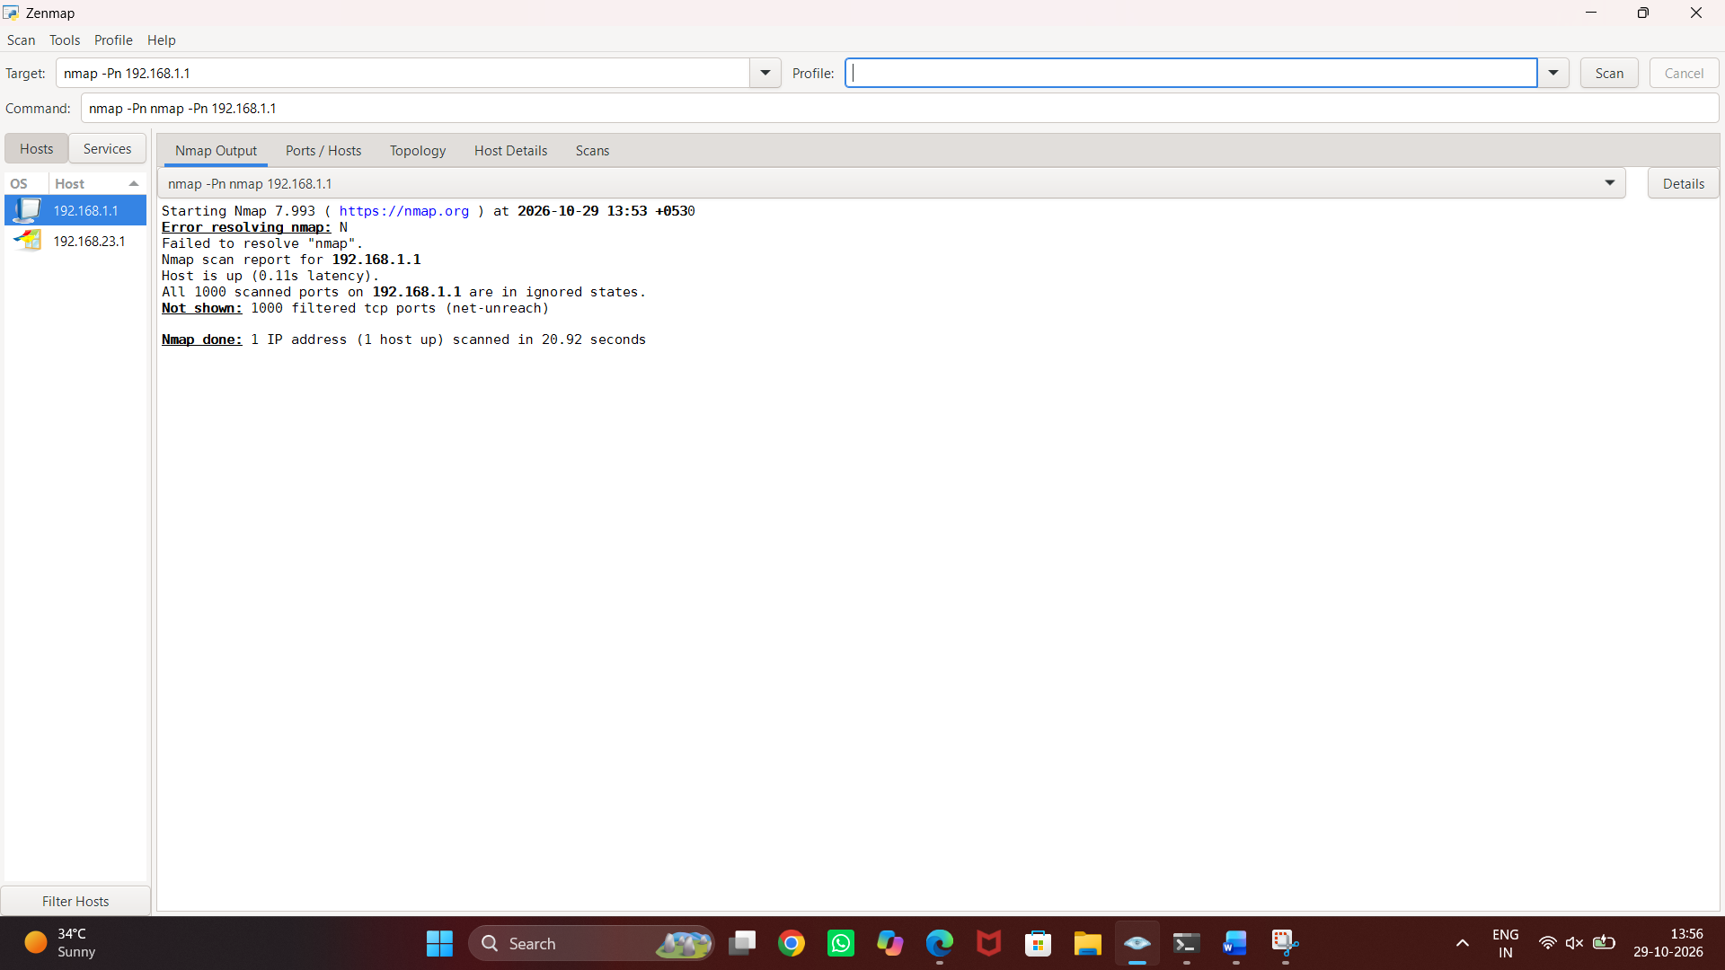

8. nmap -oN scan.txt 192.168.1.1
Purpose: Save scan results to a file
